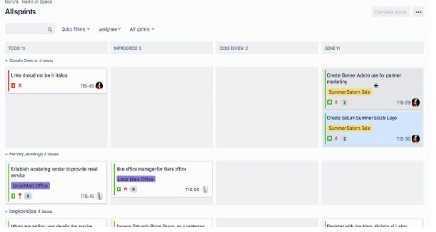Sprint Review Tasks

Current Goal: Create a GUI control on the base website that allows a user to select a date and create an event. And controls to edit/delete said event.

# Start and Welcome – 10 minutes (15 if new team)

Welcome the Stakeholders (icebreaker)

Introductions if needed (new Teams)

Present Agenda and Timeframes

Review Sprint Goal

# Demo and presentations – 20 to 30 minutes

Review stories and completed tasks

Present Release or Demo (client interaction)

Present highlights

# Feedback: Current Sprint – 30 minutes

Stakeholder feedback session (Customers)

Was new feature well received and considered done?

Positive Feedback review

Suggestions and Scope change feedback review (if possible)

# Product Backlog – 10 minutes

Scope adjustment?

Not completed Tasks

Upcoming Sprint: Head of Backlog

Critical Tasks defined

# Feedback 2: Next Sprint – 30 to 45 minutes

Stakeholder feedback session on tasks/sprint

Set Sprint Goal (agree upon)

Positive Team Feedback (acknowledgements)

Suggestions and Questions